**LAB PROJECT REPORT**



**Spring 2025**

**CSE303L Data Communication and Computer Networks Lab**

Submitted by:

**Muhammad Ibad Khan (22pwcse2170)**

**Muhammad Talha Khan (22pwcse2213)**

**Muhammad Maaz (22pwcse2204)**

Class Section: **A**

“On my honor, as student of University of Engineering and Technology, I have neither given nor received unauthorized assistance on this academic work.”

Submitted to:

**Dr.Yasir Saleem Afridi**

July 2, 2025

**Department of Computer Systems Engineering**

**University of Engineering and Technology, Peshawar**

***PROJECT REPORT***

**Home Devices Connection with IoT Server using Packet Tracer:**

**Introduction:**

The project showcases a **smart home automation system** designed in **Cisco Packet Tracer**, where IoT-enabled devices (fan, AC, garage, door, light, humidity sensor) are connected to an **IoT server** via a network consisting of a **router, switch, and end-user devices** (PCs, laptops, and smartphones). The system allows users to monitor and control home appliances remotely through a **web-based dashboard**, enhancing convenience, energy efficiency, and security.

**Objectives:**

1. **Network Design**: Configure a functional home network with a **router, switch, IoT server, and smart appliances**.
2. **IoT Integration**: Register and control devices (fan, AC, door, light, sensor) via the **IoT server dashboard**.
3. **Remote Access**: Enable users to interact with appliances through a **web interface** from any connected device.
4. **Real-Time Monitoring**: Display live status (ON/OFF, speed, lock state, humidity levels) for all connected devices.

**Implementation:**

**Network Setup (Based on Provided Image)**

1. **Devices Used**:
   * **Router**: Connects the home network to the internet (simulated in Packet Tracer).
   * **Switch**: Links all IoT devices and user endpoints.
   * **IoT Server**: Hosts the web interface (http://10.1.2.2/home.html) for device control.

* + **Appliances**:
    - **Fan**: Adjustable speed (Low/High).
    - **AC**: ON/OFF control.
    - **Door/Garage**: Open/Close and Lock functionality.
    - **Light**: Dimmer and ON/OFF switch.
    - **Humidity Sensor**: Real-time readings (e.g., 63%).
  + **User Devices**: PC, Laptop, Smartphone (for accessing the dashboard).

1. **IP Configuration**:
   * IoT Server: 10.1.2.2 (as seen in the image).
   * Devices are assigned IPs within the same subnet for communication.
2. **IoT Server Dashboard (From Image)**:
   * **URL**: http://10.1.2.2/home.html (accessible via browser).
   * **Features**:
     + Toggle switches for appliances (e.g., Fan speed, AC power).
     + Status indicators (e.g., "Open" for doors, "63" for humidity).
     + Lock controls for doors/garage.
3. **Device Registration**:
   * Each appliance is registered with a unique ID (e.g., PTT0810101U for the Fan).

**Working:**

1. **User Access**:
   * A user opens a browser on a PC/laptop/smartphone and navigates to http://10.1.2.2/home.html.
2. **Control & Monitoring**:
   * **Fan**: Switch between Low/High speed.
   * **AC**: Turn ON/OFF. o **Door/Garage**: Lock/Unlock or Open/Close. o **Light**: Adjust brightness or toggle power.
   * **Humidity Sensor**: Displays live data (e.g., "Humidity: 63%").

1. **Real-Time Updates**:
   * The IoT server logs all actions (e.g., "Garage Door: Locked") and reflects changes instantly on the dashboard.

When it is setup for the FAN

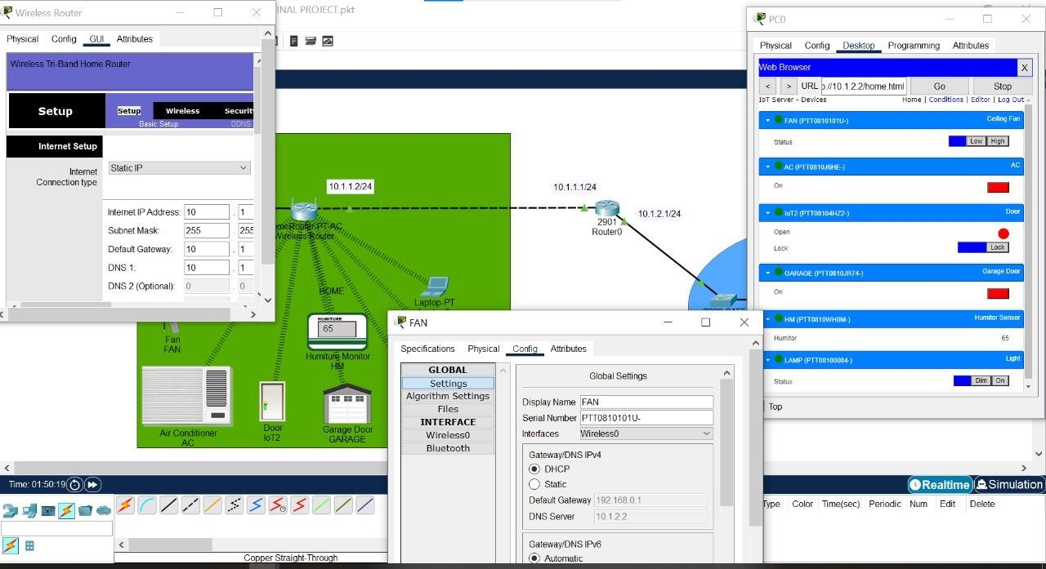

A desktop interface for all the home appliances.

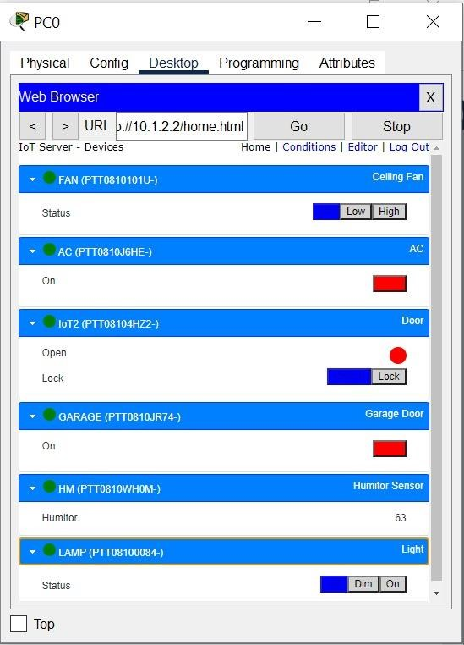

Project interface:

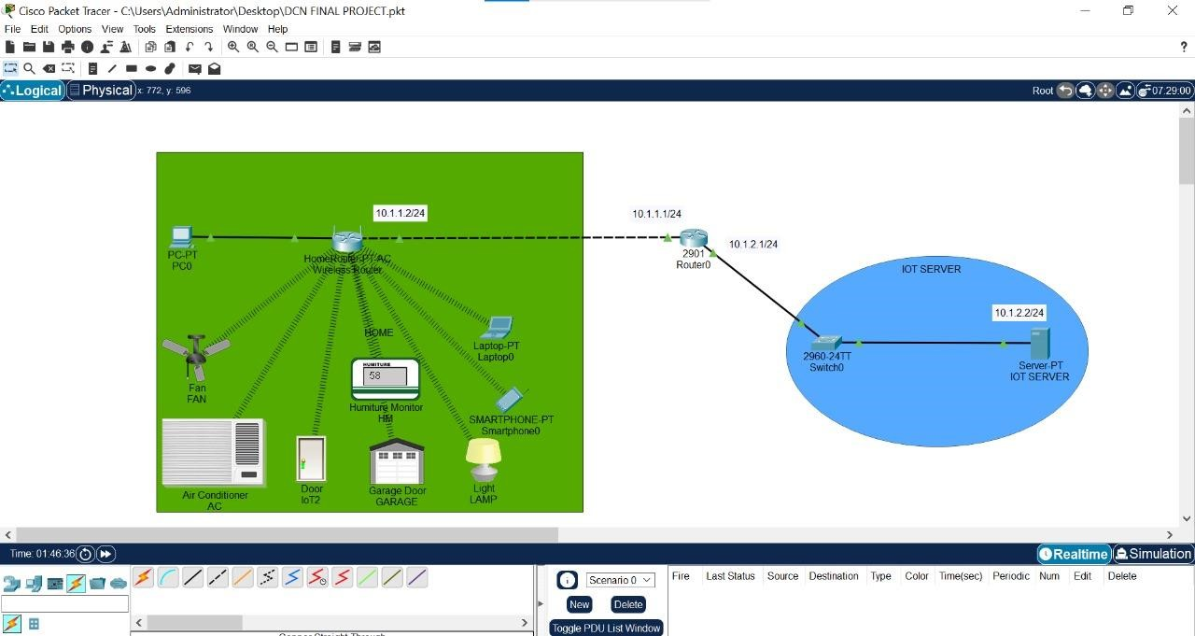

**Conclusion:**

This project successfully demonstrates a **smart home IoT ecosystem** in Packet Tracer, featuring:

* A scalable network with **router, switch, and IoT server**.
* **Web-based control** of appliances via an intuitive interface.
* **Real-time feedback** for seamless user interaction.

*THE END*